Weather-Based Prediction of Wind Turbine Energy
1. Introduction
The Wind Energy Output Estimator is a machine learning–based web application designed to predict wind turbine energy generation using real-time wind parameters. The system is trained on historical wind turbine data containing wind speed, wind direction, and active power output. Using a regression model, the application forecasts energy production for a 10-minute interval. The project integrates a Flask backend for prediction and API handling, along with weather data retrieval from the OpenWeather API. This solution demonstrates the practical application of data science and renewable energy analytics to support efficient wind power generation forecasting.

2. Project Overview
- Purpose:
The purpose of this project is to build a machine learning–based system that predicts wind turbine energy output using historical turbine data and live weather inputs.
- Features:
  - Data preprocessing and cleaning.
  - Random Forest regression model for prediction.
  - Flask-based web dashboard for user interaction.
  - Integration with OpenWeather API for real-time weather data.
  - Visualization of actual vs predicted power outputs.

3. Architecture
- Frontend:
Flask templates (HTML, CSS, JavaScript) used for UI design and dashboard visualization.
- Backend:
Python Flask application handling API requests, ML model predictions, and weather data integration.
- Database:
Local CSV dataset (info.csv) for training and testing. Model stored as .sav file using Joblib. Future scope includes cloud database integration (MongoDB Atlas / AWS RDS).

4. Setup Instructions
- Prerequisites:
  - Python 3.9+
  - Flask
  - Pandas, NumPy, Scikit-learn, Matplotlib
  - Joblib
  - OpenWeather API key
- Installation:
  - Clone the repository.
  - Install dependencies using pip install -r requirements.txt.
  - Set up environment variables (API key for OpenWeather).
  - Run the Flask server with python app.py.

5. Folder Structure
- Client (Frontend):
  - templates/ → HTML files (intro page, dashboard).
  - static/ → CSS, JS, and images.
- Server (Backend):
  - app.py → Flask application.
  - train_model.py → ML model training script.
  - power_prediction.sav → Saved Random Forest model.
  - data/ → Dataset files.
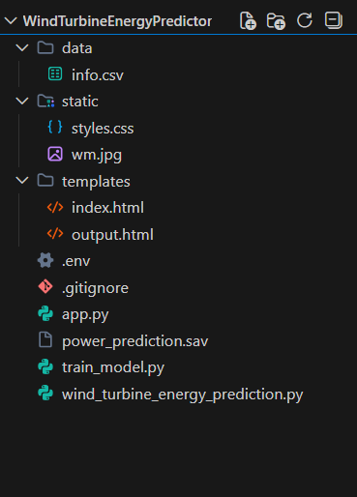

6. Running the Application
- Frontend: Runs automatically via Flask templates.
- Backend: Start with python app.py.
- Access at http://127.0.0.1:5000/.
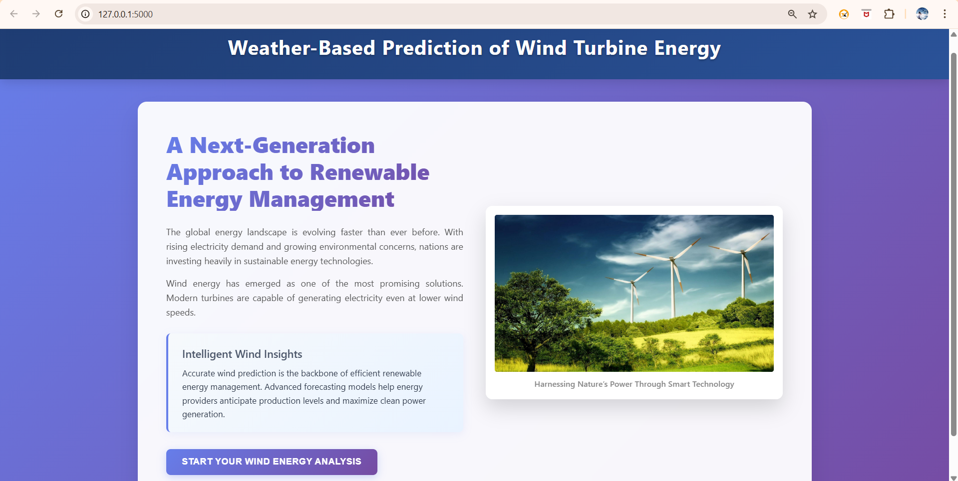

Here is the correct and updated API documentation based on your current Wind Energy Prediction project (where inputs are Wind Speed and Wind Direction, and the model predicts energy generation for a 10-minute interval).

Here is the correct and updated API documentation based on your current Wind Energy Prediction project (where inputs are Wind Speed and Wind Direction, and the model predicts energy generation for a 10-minute interval).

7.API Documentation
• Endpoint 1: /predict
- Method: POST
- Description:
This endpoint predicts the wind turbine’s energy generation (kWh) for a 10-minute interval using a trained machine learning model.
- Request Parameters (JSON body):
  - wind_speed (float): Measured wind speed in meters per second (m/s)
  - wind_direction (float): Wind direction in degrees (°)
- Example Request Body:
{
"wind_speed": 5.6,
"wind_direction": 267
}
Response:
  - predicted_energy_kwh (float): Predicted energy output in kWh
Example Response:
{
"predicted_energy_kwh": 67.56
}

• Endpoint 2: /weather
- Method: GET
- Description:
This endpoint retrieves real-time weather data for a given city using the OpenWeather API. The data can be used to assist in wind energy forecasting.
- Query Parameter:
  - city (string): Name of the city
- Example Request:
/weather?city=Delhi
- Response:
  - temperature (float): Current temperature
  - humidity (int): Humidity percentage
  - pressure (int): Atmospheric pressure (hPa)
  - wind_speed (float): Wind speed (m/s)
  - wind_direction (float): Wind direction (degrees)
- Example Response:
{
"city": "Delhi",
"temperature": 30,
"humidity": 62,
"pressure": 1008,
"wind_speed": 4.8,
"wind_direction": 250
}

8. Authentication
- Currently open access.
- API key required for OpenWeather API integration.
- Future scope: JWT-based authentication for secure access.

9. User Interface
- Intro page with project overview.
- Dashboard with:
  - Weather data display.
  - Prediction module.
  - Visualization graphs.
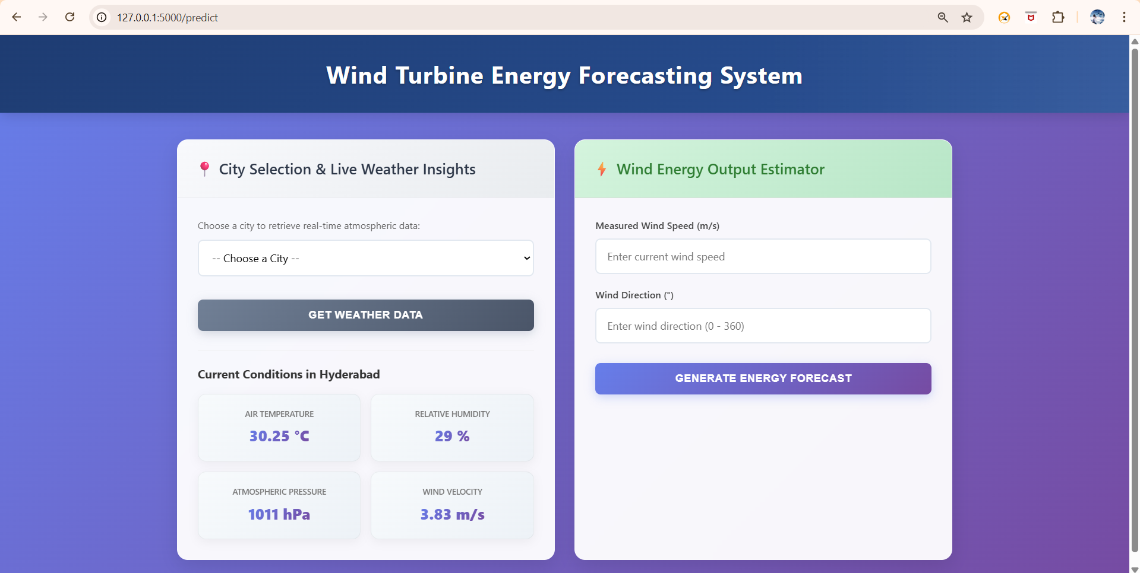

10. Testing
- Unit testing for ML model predictions.
- API testing for weather data retrieval.
- Functional testing for input validation and dashboard navigation.
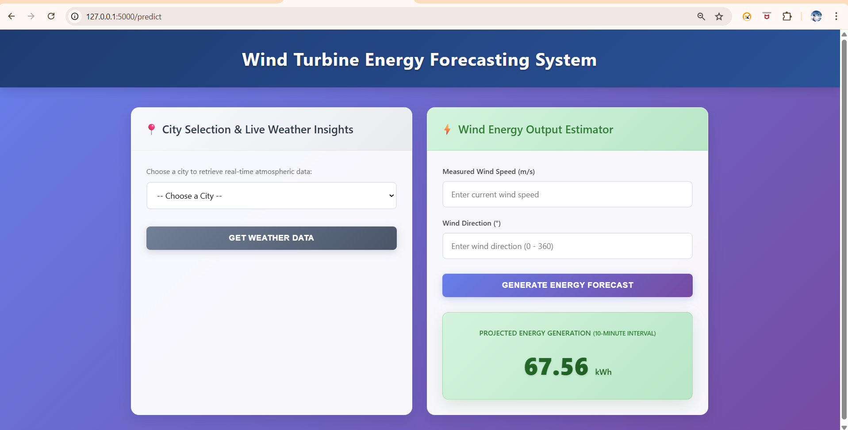
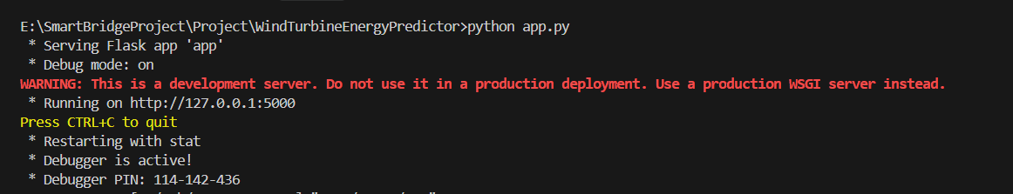

11. Screenshots or Demo
- Scatter plot of actual vs predicted power.
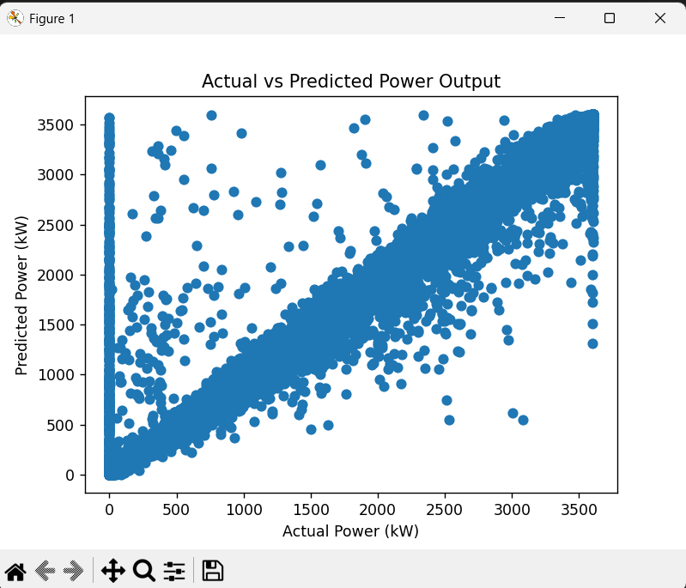
- Dashboard screenshot showing weather + prediction results.
- Line chart trends of wind speed vs power output.

12. Known Issues
- Limited dataset size may affect generalization.
- API errors if invalid city names are entered.
- No authentication for dashboard access (future enhancement needed).

13. Future Enhancements
- Deploy on cloud (AWS/GCP/Azure).
- Add JWT authentication for secure access.
- Expand dataset for improved accuracy.
- Add more visualizations (heatmaps, time-series forecasting).
- Integrate grid demand APIs for real-time energy balancing.

14. Conclusion
The Wind Turbine Energy Prediction project successfully demonstrates the application of machine learning and data-driven techniques to solve a real-world renewable energy challenge. By leveraging historical turbine data, preprocessing methods, and a Random Forest regression model, the project achieves strong predictive accuracy, enabling stakeholders to forecast energy output with confidence.
The integration of a Flask-based dashboard and OpenWeather API ensures that predictions are not only technically sound but also accessible and user-friendly. Visualizations such as scatter plots, line charts, and correlation heatmaps further enhance interpretability, making the solution practical for energy companies, wind farm operators, and grid managers.
Through structured Agile sprint planning, backlog management, and performance testing, the project was executed with clarity and measurable progress. Testing confirmed the robustness of the model, while defect analysis and bug tracking highlighted areas for improvement.
Ultimately, this project provides a scalable foundation for future enhancements, including cloud deployment, advanced authentication, expanded datasets, and integration with grid demand APIs. It stands as a strong example of combining data science, software engineering, and agile methodology to deliver a solution that addresses both technical and customer-centric needs in the renewable energy sector.

